**Software Requirements**

**Specification**

**for**

**Resort Reservation System**

**Version 1.0 approved**

Prepared by:  
Reyes, Hannah Mae E.  
Lee, Kyle Vincent V.  
Belchez, Maica L.

BSIT-MI141

Asia Pacific College

October 2016

**Copyright © 1999 by Karl E. Wiegers. Permission is granted to use, modify, and distribute this document.**

**Software Requirements Specification for <Project> Page ii**

# Table of Contents

Table of Contents 2

Revision History 2

1. Introduction 1

1.1 Purpose 1

1.2 Document Conventions 1

1.3 Intended Audience and Reading Suggestions 1

1.4 Product Scope 1

1.5 References 2

2. Overall Description 2

2.1 Product Perspective 2

2.2 Product Functions 2

2.3 User Classes and Characteristics 6

2.4 Operating Environment 7

2.5 Design and Implementation Constraints 8

2.6 User Documentation 8

2.7 Assumptions and Dependencies 8

3. External Interface Requirements 8

3.1 User Interfaces 8

3.2 Hardware Interfaces 9

3.3 Software Interfaces 9

3.4 Communications Interfaces 9

4. System Features 9

4.1 System Feature 1 9

4.2 System Feature 2 (and so on) 10

5. Other Nonfunctional Requirements 10

5.1 Performance Requirements 10

5.2 Safety Requirements 10

5.3 Security Requirements 11

5.4 Software Quality Attributes 11

5.5 Business Rules 11

6. Other Requirements 11

Appendix A: Glossary 12

Appendix B: Analysis Models 12

Appendix C: To Be Determined List 13

# Revision History

|  |  |  |  |
| --- | --- | --- | --- |
| **Name** | **Date** | **Reason For Changes** | **Version** |
| Maica L. Belchez | 10/22/2016 | Create Operating Environment, Reference, Hardware Interfaces, Performance Requirements, Safety Requirements, User Documentation | 1.0 |
| Maica L. Belchez | 10/29/2016 | Create User Classes and Characteristics, Security Requirements, Business Rules, Product Scope, Intended Audience and Reading Suggestions, Document Conventions | 1.1 |
| Maica L. Belchez  Kyle Vincent V. Lee  Hannah Mae E. Reyes | 10/31/2016 | Create Purpose, Assumptions and Dependencies, Product Perspective, Design and Implementation Constraints, Other Requirements, Software Quality Attributes | 1.2 |
| Maica L. Belchez  Kyle Vincent V. Lee  Hannah Mae E. Reyes | 11/3/2016 | Create Glossary, Software Interfaces, Analysis Models, Communications Interfaces, Product Functions | 1.3 |

# Introduction

## Purpose

The Software Requirements Specification (SRS) will provide a detailed description of the requirements for the Resort Reservation System. This SRS will consider a complete understanding of what is to be relied upon of the system to be built. The clear understanding of the system and its’ functionality will allow for the correct software to be created for the end user and will be utilized for the improvement of the future stages of the project. This SRS will give the establishment to the project. From this document, the system can be designed, developed, and finally tested.

This SRS will be utilized by the developers constructing the Resort Reservation System and the client. The developers will use this document to completely comprehend the desires of this system to build the appropriate software. The client will have the ability to utilize this document as a “test” to check whether the developers will build the system to his expectations. The client can point out the things that did not meet his standards and expectations, and the developers will change the SRS to fit the client's needs.

## Document Conventions

The document is prepared using Microsoft Word 2016; has used the font type ‘Times New Roman’ for the headings and ‘Arial’ for the contents. The fixed font size that has been used to type this document is 11pt with 1.0 line spacing. It has used the bold property to set the headings of the document.

## Intended Audience and Reading Suggestions

The intended audience of this document are the owner and specific employees of the resort, such as manager and receptionist of Tarangban Falls & Calimbo Farm Resort, and developers with the goal to refer and analyze the data. The SRS document can be utilized as a part of any case with respect to the requirements of the project and the arrangements that have been taken. The document would final provide a reasonable thought regarding the system that is building.

Brief outline of the document is:

1. Overall Description

2. System Features

3. External Interface Requirements

4. Non-Functional Requirements

## Product Scope

The introducing software, Resort Reservation System which will be implemented for Tarangban Falls & Calimbo Farm Resort, will automate the significant operations of the resort. Its features are to keep track of room and hall reservation, and check availability; to manage all room types and services, and to keep track in all inventories of the resort and customer information. The owner, manager, receptionist and customer are the four end users of Resort Reservation System. The owner can access all system functionalities without limitations. The manager can only access system functionalities assigned to him or her. The receptionist can only access the reservation management section. The customer can only view the site’s contents, book a reservation, and register an account. To keep limitations for user levels access, Resort Reservation System can make a distinctive login functions.

The objectives of the automated Resort Reservation System are to streamline the process of the resort quick and timely manner. The system will have the capacity to handle numerous services to deal with all customers in a quick and timely manner. As a solution for the vast measure of file handling happening at the resort, this software will be utilized to overcome those downsides. Safety, the effectiveness of utilization, and the proficiency of data recovery are a few advantages the developers going to give this system. The system ought to be user-friendly, provide easy recovery of errors and have an overall end user high subjective fulfillment.

## References

World Wide Web:

[1] <http://projects2.apc.edu.ph/wiki/index.php/Project_-_Resort_Reservation_System_-102>  
[2] <http://projects2.apc.edu.ph/wiki/index.php/Project_-_Resort_Reservation_System_%28Part_2%29_-_102>  
[3] <https://github.com/seans888/Project---Reservation-System>

# Overall Description

## Product Perspective

The Resort Reservation System is a self-contained software which will be produced by the developers to help the client manage his own resort using the proposed system. The recently presented system will give a simple access to the system and it will contain user-friendly functions with attractive interfaces. The system will give better alternatives for the issue of handling large scale of the physical file system, for the errors happening in calculations and the various required tasks that have been indicated by the client. The final result of this project will increase the effectiveness of the considerable number of tasks done at the resort in a much convenient way.

## Product Functions

Based on the requirements of the client, the Resort Reservation System functions are listed below:

* Make reservations
* Search rooms availability
* Manage guests/clients or customers
* Manage room details
* Manage staff
* Manage users
* Manage services

Data Flow Diagram

Level 0

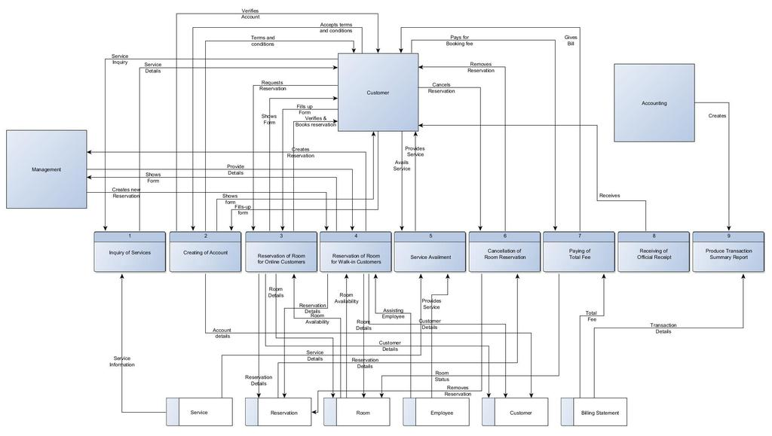

Level 1

Creating of Account

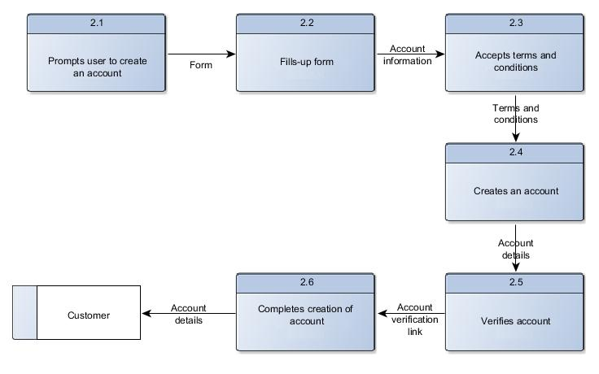

Reservation of Room for Walk-in Customers

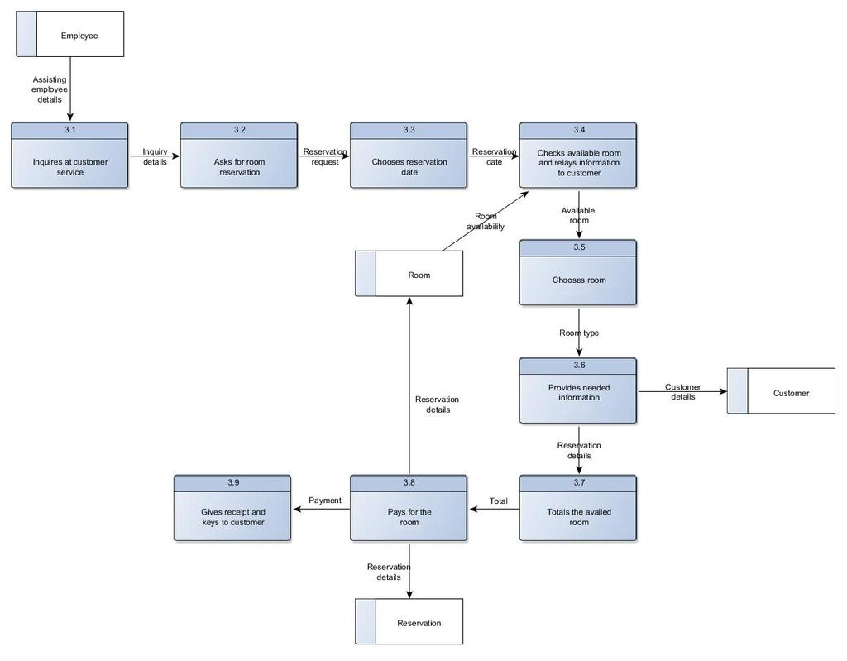

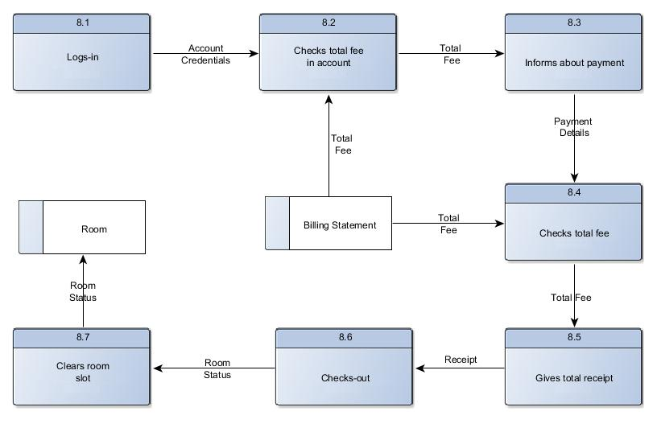Reservation of Room for Online Customers

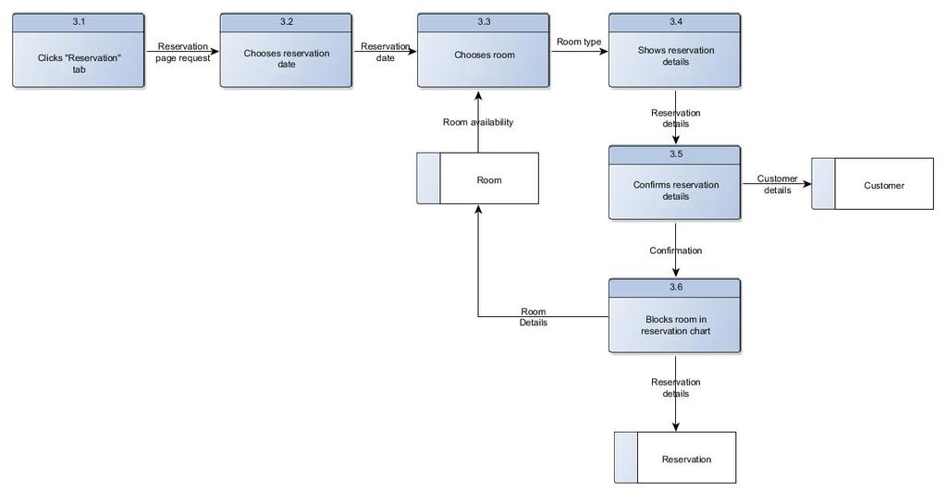

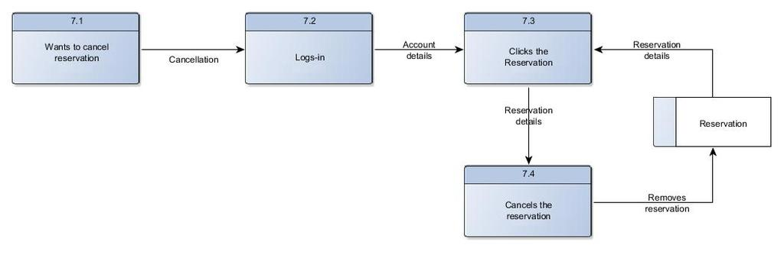Cancellation of Room Reservation

## User Classes and Characteristics

**2.3.1 User Classes**

There are four user levels in Resort Reservation System of Tarangban Falls & Calimbo Farm Resort.

1. Owner (Client)
2. Manager
3. Receptionist
4. Customer

**2.3.2 Characteristics of User Classes**

Owner:

The resort owner has the right in monitoring and authorizing all the tasks handled by the system. He or She can access every function performed by the system. The owner of the resort can access to the administration panel that is considered the center of the system. As the head authorized person of the resort, the owner gets the capability to manage the other users including their user levels and privileges. The owner/admin can conduct system backups and recovery on-site or remote. Then, he or she will be capable of taking all the sorts of reports accessible in the system. As the owner of the resort and the system, he or she has the power to set room rates as well. The owner has the sole right of managing staff access in the system database.

Manager:

The manager is in charge of managing assets accessible in resort reservation system. The manager also has a large portion of the privileges specified above with the exception of the things in regards to the payment handling. The explanation behind utilizing a manager is to reduce the workload done by the owner that can’t be allotted to the receptionist, as those tasks appear to be much dependable. The manager has the right to take every report accessible in the system yet here also with the exception of the reports related to financial stuff, and resort income. The manager has various capacities that receptionist, user level has such as adding new employees, guests, inventories, and room types to the system. Also, modifying or removing them in the system.

Receptionist:

As a resort receptionist, his or her part will be to achieve the objectives of bookings and to guarantee that all customers are treated with a high standard of customer service. Progressively, receptionist role has minimal accessibility to the system capacities. Receptionist plays the boundary role of the system. He or She can perform limited functions such as registering new guest to the system, make reservations, sending e-mail notifications to customers for booking confirmation. Management of the resort will prefer to contract receptionist who has a decent standard of general education and perhaps in subjects such as English, Math, and IT.

Customer:

The customer is the one who will be using the very system that is being created. They are in charge of creating a reservation in the website. They are also the one who will populate the system by registering an account. They are to provide accurate and honest information so that the management can better serve them. The customer can perform limited functions such as registering an account, booking a reservation, sending an email feedback/report to management through the website, and viewing the site’s contents.

## Operating Environment

Hardware and Software requirements

Hardware:

1. Operating System: Supports all known operating systems, such as Windows, Linux
2. Computer: 512MB+ RAM, monitor with minimum resolution of 1024x768, keyboard, and mouse
3. Hard Drive: should be in NTFS file-system formatted with minimum 10 GB of free space
4. Printer: need to be used to print reports and notes

Software:

1. Software is designed to run on any platform above Microsoft Windows 7
2. Microsoft .NET Framework 4.0 or above
3. Microsoft SQL Server Management Studio Express 2010
4. Software can be used on any browsers

## Design and Implementation Constraints

The developers give their best effort in developing the system. With a specific end goal to maintain the reliable and durable of the system. Some design and implementation constraints are applied. Accessibility of an android application for resort reservation system could make the system portable yet because of time requirement, it is not possible. When designing interfaces of the system, the developers had the capability of work with tools such as Yii2.

## User Documentation

System and user manuals will be written and provided under the client’s perspective and understanding. It will be composed in a straightforward language covering the internal complexity of the system. A printed copy of the user manual will be delivered to the client with the delivery of the system.

## Assumptions and Dependencies

Assumptions:

* The essence of the online application requires customer/server design, network hardware and software, server hardware and software, and database software.
* The system will display the inventory continuously and show future returns, which will permit customers to make reservations accordingly.
* Additional training of the management is expected for them to handle new protocols, hardware, and software.

Dependencies:

* Building relations with different software and hardware will satisfy the requirements of the project.
* This should expand management efficiency, consequently increasing revenue through customer satisfaction.
* Additional training time allowed for the management.

# External Interface Requirements

## User Interfaces

<Describe the logical characteristics of each interface between the software product and the users. This may include sample screen images, any GUI standards or product family style guides that are to be followed, screen layout constraints, standard buttons and functions (e.g., help) that will appear on every screen, keyboard shortcuts, error message display standards, and so on. Define the software components for which a user interface is needed. Details of the user interface design should be documented in a separate user interface specification.>

## Hardware Interfaces

Section 2.4 includes the requirements of the desktop computer where the system going to be installed. A specific computer must match with the above mentioned requirements in order to gain the maximum benefits from the system in an efficient manner.

Reservation alerts will be sent to one of the members of hotel employee as an e-mail notification. So there is a need of broadband internet connection. The client should be able to keep a stable internet connection.

Also, a printer will be needed when printing bills and several reports.

## Software Interfaces

The computer, this software going to be installed, needs to have Windows Operating System above Windows 7. On Windows platform, .Net 4.0 will be installed and will be the platform specific software that will run. There will be an ADO.NET data transmission with the Microsoft SQL Server Management Studio Express 2010 R2 edition that will be installed on the same computer. Then, the web application can run on all browsers.

## Communications Interfaces

The application software will be here an association with e-mails, wherein it will make use of the email for sending updates about the reservation made, and/or confirmation of customer account. Since the application is a website, it also is associated, of course, with a web browser. To access the website, the user must be first connected to an internet connection and must have a web browser of any kind. The application will use the Hypertext Transfer Protocol for data communication. With that, security features must also be implemented since there are possible sensitive data that will be gathered during a transaction. When a customer, makes a reservation online, credentials are needed for the application to confirm that reservation, if not careful, these pieces of information containing user identity and information that can be used by other people for illegal purposes.

# System Features

## User Registration

4.1.1 Description and Priority

This feature describes how the user can register and how they are managed

Priority: High

4.1.2 Stimulus/Response Sequences

A user wants to login to the system and use it, so he/she needs to register an account to be able to accomplish said goal.

4.1.3 Functional Requirements

REQ-1: A user must be able to register an account into the system

REQ-2: A user must be classified as regular customer, an employee, or an administrator

REQ-3: After registration, a user must be able to log into the system.

REQ-4: A user must have privileges in accessing the system based on their user status

REQ-5: A user must be able to reset their password

REQ-6: A user must be able to receive notifications

REQ-7: A user must be able to send feedback through the ‘Contact us’ page

## Administration

4.2.1 Description and Priority

This feature describes what functionality the administrators have in the system

Priority: High

4.2.2 Stimulus/Response Sequences

An administrator would like to view reservations and update users

4.2.3 Functional Requirements

REQ-1: Administrator must be able to grant administrator status

REQ-2: Administrator must be able to revoke administrator status

REQ-3: Administrator must be able to view all listed reservations

REQ-4: Administrator must be able to delete reservations

REQ-5: Administrator must be able to add user

REQ-6: Administrator must be able to remove user

REQ-7: Administrator must be able to remove user’s privileges

REQ-8: Administrator must be able to view transaction log which contains information about the events happening in the system

REQ-9: Administrator must be able to clear log

REQ-10: Administrator must be able to save a copy of the log

## Reservation

4.2.1 Description and Priority

This feature describes how a user can reserve for a room

Priority: High

4.2.2 Stimulus/Response Sequences

A user wants to avail for a service and reserve a room

4.2.3 Functional Requirements

REQ-1: User must be able to create a reservation based on interest

REQ-2: User must be able to pick a date for the reservation

REQ-3: User must be able to input all required data for reservation

REQ-4: User must be able to view all of their made reservations

REQ-5: User must be able to cancel made reservations

REQ-6: User must be able to pay online

REQ-7: User must be able to receive emails for notifications

# Other Nonfunctional Requirements

## Performance Requirements

Performance requirements define sustainable response times for system functionality. Despite the fact that the system is created suiting for the least system performances, the performance of the system will highly depend on the performance of the hardware and software components of the installing computer. At the point when considering the timing relationships of the system, the load time for user interface screens might take no longer than two seconds. It makes fast access to system functions. The login details shall be verified within five seconds causes’ efficiency of the system. Returning query results within five seconds makes search function more accurate.

## Safety Requirements

There are several user levels roles in resort reservation system, access to the different subsystems will be ensured by a user login that requires a username and password. This gives different perspectives and accessible functions of user levels through the system. Maintaining backups ensure the system database security. System restore can be made in case of emergency.

## Security Requirements

Receptionists, Managers, and Owner will be able to log in to the Resort Reservation System. The receptionist will have access to the Reservation/Booking subsystems. On the other hand, managers access to the Management subsystem, as well as the Reservation/Booking subsystems. The owner has the maximum privilege to all subsystems. Access to the different subsystems will be secured by a user login screen that demands unique username and password.

## Software Quality Attributes

* Adaptability – The system ought to have the capacity to effortlessly acknowledge the progressions. If any time something new is introduced to the system, it is necessary that it can accept changes easily.
* Availability – The system roles shall be available during resort operating hours
* Efficiency – How significantly less number of assets and time are required to accomplish a specific errand through the system.
* Maintainability – How simple is to keep restore can be made in and adjust defects with making improvements. What outline, coding standards must be adhered to rejections made.
* Reliability – Determine the variables required to set up the required reliability of the software system at the time of delivery. Mean time amongst failures and mean time to recovery.
* Reusability – What is the capacity to utilize the accessible parts of the system in different systems too.
* Robustness – Quality of the system to handle system functions precisely and keep up the database without confronting to unexpected failures.
* Security – Access to the different subsystems will be secured by a user login screen that requires username and password.
* Testability – Effort expected to test to guarantee performs as planned.
* Usability – How effectively a person can be taken the advantages of the system and the ease of use.

## Business Rules

Resort Reservation System will work under four users those are Owner, Manager, and Receptionist and Customer. The system is designed in a way were function and privileges are lessened in the part of the owner, manager, and receptionist and customer. The part of manager is chosen to the point of making the owner’s hands free from general interfering with the system. In this way, the vast majority of the privileges that the owner has are given to the manager, except the ones that are critical and important. Some features like that are taking backup, re-establishing of the system and handling financial information, hotel income reports of the system. The receptionist is given with the most oftentimes utilized features of the system which have less function than the other two users. Deleting any information in the system is only authorized for the owner of the resort. The customer is

# Other Requirements

The another requirement needed for the Resort Reservation System is security. The system will include a log-in form. The administrator and the customer will be the two levels of access in the system. And when the system is completely developed and submitted to the client, a couple of sessions will be required to make the users of the system understand the functionality of it and some time to adjust to the system.

# Appendix A: Glossary

* Accommodations – a place where travelers or vacationers can sleep and find other services
* Amenities – hotel products and services designed to attract guests
* Booking – an act of reserving an accommodation, a trip, a flight, etc. in advance
* Check-in – the process whereby a customer announces their arrival at the hotel
* Check-out – settle one’s hotel bill before leaving
* Online Guest – guest who reserve a room rental through online
* Reservation – an arrangement by which accommodations are secured in advance
* Resort Hotel – a full-service lodging facility, intended primarily for vacationers and usually located in places frequented for relaxation or recreation
* Transaction – the exchange of merchandise, property, or services for cash or a promise to pay
* Walk-in Guest – guest who request a room rental without having made a reservation

# Appendix B: Analysis Models

This diagram was analyzed based on the requirements of the client.

Entity Relationship Diagram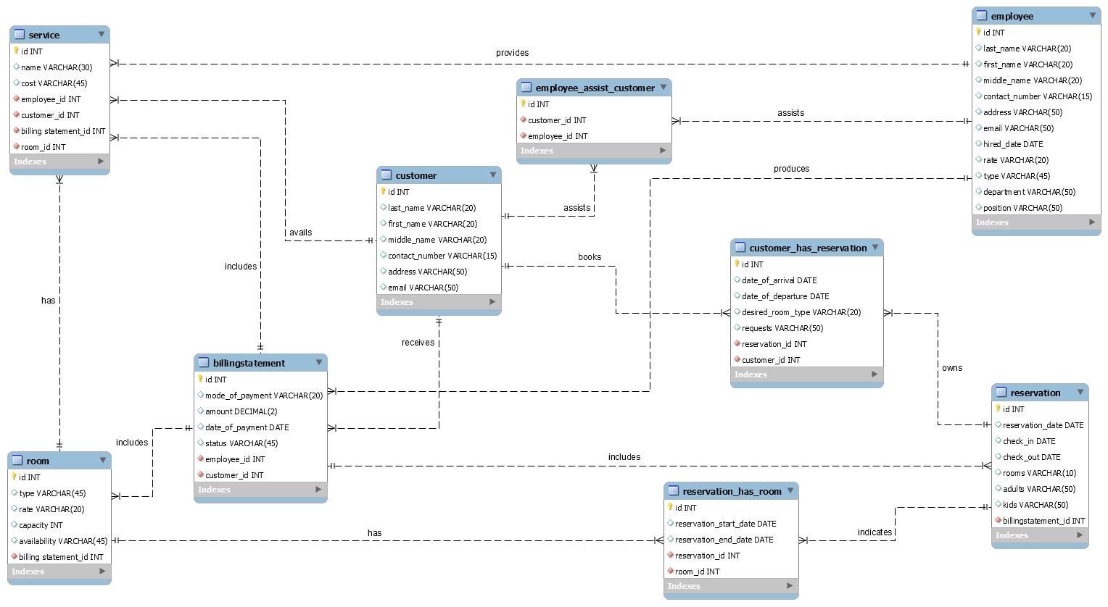

# Appendix C: To Be Determined List

<Collect a numbered list of the TBD (to be determined) references that remain in the SRS so they can be tracked to closure.>